**XCELERA DDE**

**Left Ventricle Ejection Fraction (LVEF)**

**Results to Cerner**

**Version 1.3**

**Prepared By: Tiffany Bohall & Sarah Thies**

**Date: 6/18/2019**

Document Control 3

Resources 3

Document Version Control 3

1. Introduction 4

1.1 Purpose 4

1.2 Project Scope 4

1.3 Terminology Standards 4

1.3.1 Acronyms 4

1.3.2 Glossary 4

1.4 Document References 4

*2.* Diagram 5

3. Requirements 6

3.1 Functional Requirements 6

3.2 Non-Functional Requirements 6

3.3 Messaging Protocols 7

3.3.1 Inbound to BayCare Cloverleaf 7

3.3.2 Outbound from the BayCare Cloverleaf 7

3.3.3 Inbound to BayCare’s Cloverleaf 7

3.3.4 Outbound from BayCare’s Cloverleaf 7

3.3.5 Cerner Protocols 7

4. HL7 Messaging 8

4.1 Messaging Format 8

4.1.1 Segments 8

4.1.2 Messaging Event Types 8

4.1*.*3 Cloverleaf Configuration Files 9

4.1.4 Cloverleaf Site Location 9

4.2 Data Transformation Requirements 9

4.2.1 Cerner Results inbound 9

4.3 Sample Messages 11

4.3.1 Xcelera Inbound 11

4.3.2 Outbound to Cerner 11

5. Alerts 12

Appendix A: Risks and Concerns -N/A 13

Appendix B: Issues List -N/A 13

# **Document Control**

## Resources

|  |  |  |
| --- | --- | --- |
| **Name** | **Role** | **Email** |
| Gus Borrego | BayCare IS Director: Applications | [Gus.Borrego@baycare.org](mailto:Gus.Borrego@baycare.org) |
| Joyce La Chapelle | BayCare IS Manager: Ancillary Systems | [Joyce.Lachapelle@baycare.org](mailto:Joyce.Lachapelle@baycare.org) |
| Cheri Krampert | BayCare IS Manager: Enterprise Integration and HIE | [Cheryl.Krampert@baycare.org](mailto:Cheryl.Krampert@baycare.org) |
| Heather Morrison | BayCare IS Supervisor: Clinical Systems | [Heather.Morrison@baycare.org](mailto:Christopher.Constantinou@baycare.org) |
| Tiffany Bohall | BayCare Integration Analyst | [Tiffany.Bohall@BayCare.org](mailto:Tiffany.Bohall@BayCare.org) |
| Rich Allison | BayCare SR Integration Analyst | [Rich.Allison@BayCare.org](mailto:Rich.Allison@BayCare.org) |
| Sarah Thies | BayCare Integration Analyst | [Sarah.Thies@baycare.org](mailto:Leann.Tabler@baycare.org) |
| Shannon Temming | BayCare SR Systems Analyst | [Shannon.Temming@baycare.org](mailto:Shannon.Temming@baycare.org) |
| Susan Benhart | BayCare SR Systems Analyst | [Susan.Benhart@baycare.org](mailto:Susan.Benhart@baycare.org) |
| Spencer Hart IV | BayCare SR Systems Analyst | [Shannon.Carey@baycare.org](mailto:Lois.Whitley@baycare.org) |
| Shannon Carey | BayCare Systems Analyst | [Shannon.Carey@baycare.org](mailto:Lois.Whitley@baycare.org) |
| Donna Buterbaugh | BayCare SR Systems Analyst | [Donna.Buterbaugh@baycare.org](mailto:Lois.Whitley@baycare.org) |
| Brian Beasley | Philips Xcelera Project Manager | [brian.beasley@philips.com](mailto:brian.beasley@philips.com) |
| Kelly Franz | Philips Integration resource | [kelly.franz@philips.com](mailto:kelly.franz@philips.com) |
|  |  |  |

## Document Version Control

|  |  |  |  |
| --- | --- | --- | --- |
| **Version** | **Date** | **Modifier** | **Description** |
| V1.0 | 4/25/2017 | Tiffany Bohall | Originally created |
| V1.1 | 5/3/2017 | Sarah Thies | Added Cerner Screenshots, and removed references not applicable to discrete interface |
| V1.2 | 7/27/2018 | Tiffany Bohall | Updated the interface to account for new aliases added on the vendor’s side |
| V1.3 | 6/8/19 | Lois Whitley | Updated Diagram |

# 1. Introduction

## 1.1 Purpose

This document outlines the changes required to accommodate outbound Philips DDE Ejection Fraction result messages from Xcelera to Cerner. No PDF processing or images are include with these results. All gaps will be identified and mitigated as well as any non-functional requirements needed to support the solution post implementation.

## 1.2 Project Scope

A physician has requested that ejection fraction which is a discrete data element in Xcelera, post to Cerner within PowerChart as a separete element. As such Philips has written a custom interface and will be sending these isolated ORUs to Cloverleaf, to be parsed to Cerner.

## 1.3 Terminology Standards

### 1.3.1 Acronyms

CVIS: Cardio Vascular Information Systems

DDE: Discrete Data Element

LF: Left Ventricle

EF: Ejection Fraction

### 1.3.2 Glossary

Xcelera IBE: Upgraded version of Xcelera application that incorporates PDF documents with textual results

## 1.4 Document References

**Philips Specifications: located on the Integration SharePoint site > Projects > CVIS Xcelera, Xper and PedCath folder**

* Xcelera IBE HL7 RB04 Specification

# *2.* Diagram

This is a solutions diagram that depicts the integration of components specified in this IDBB.

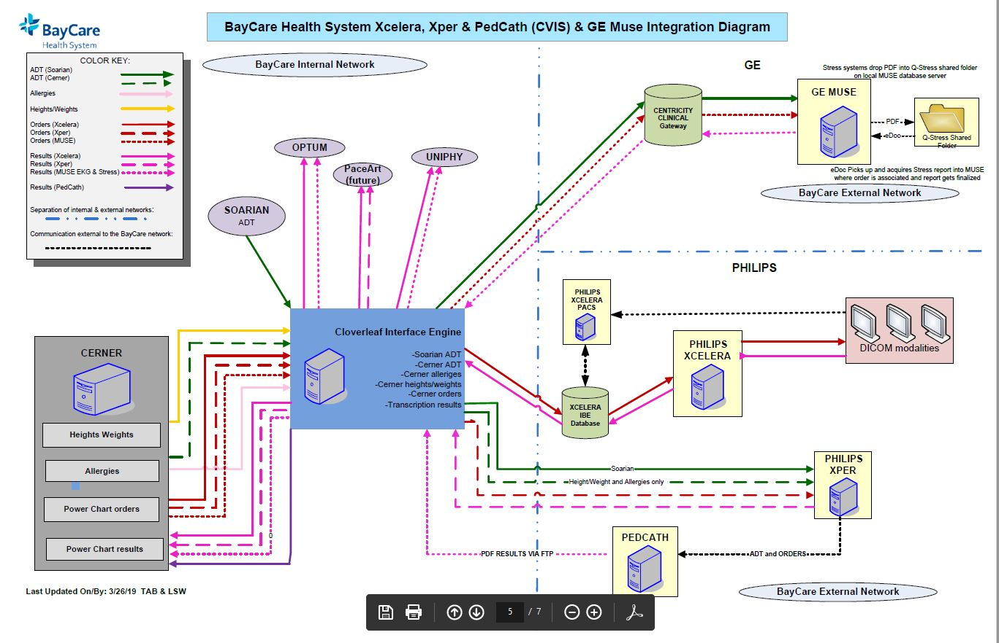

# 3. Requirements

## 3.1 Functional Requirements

Provide detail for the below functional requirements. The message transformation requirements for the components defined in this specification should be specified in section 4.2 of this document.

|  |  |  |
| --- | --- | --- |
| **Cloverleaf** |  |  |
| **Number** | **Requirement Name** | **Requirement Description** |
| FR.2017.4.25 | Ejection Fraction | If there is no SU-LV0082aa or SU-LV0082ab Philips alias for Ejection Fraction on OBX.3.1, then the entire message is discarded. |
| FR.2017.5.1 | Receiving Application | To use the existing results inbound interface, Cloverleaf changed MSH-5 value from POSTIMAGE to HNAM so Cerner will process the message as a discrete result. |
| FR.2017.5.2 | Order Number | Cloverleaf appended the value LVEF to the order number in OBR-3.1 so Cerner will break the relationship to the parent pdf and post as discrete |
| FR.2017.5.3 | Diagnostic Serv ID | Cloverleaf changed OBR-24 value from MDOC to GRP so Cerner will break the relationship to the parent pdf and post as discrete |
| FR.2017.5.4 | Value Type | Cloverleaf changed OBX-2 value from TX to ST so Cerner will break the relationship to the parent pdf and post as discrete |

## 3.2 Non-Functional Requirements

Provide concise detail for the below non-functional requirements. The below requirements must be evaluated for every project.

|  |  |  |
| --- | --- | --- |
| **Cloverleaf** |  |  |
| **Number** | **Requirement Name** | **Requirement Description** |
| NFR.2017.4.25 | Principal Result Interpreter | If the provider number in OBR.32.0 is null going to Cerner, then charges cannot be dropped for BOI locations. |
| NFR.2017.5.5 | Ordering Provider | Cloverleaf will not send an ordering provider in OBR-16 so Cerner will not send the result to the provider message center as requested. |
| NFR.2017.5.6 | ZDS Segment | Cloverleaf will not send the ZDS segment so Cerner will not send the result to the provider message center as requested. |

## 3.3 Messaging Protocols

Below are listed the details for the messaging protocols that will be leveraged for this integration.

### 3.3.1 Inbound to BayCare Cloverleaf

* oru_xcelDisc_in_IBE

### 3.3.2 Outbound from the BayCare Cloverleaf

* oru_cer_out

### 3.3.3 Inbound to BayCare’s Cloverleaf

**Test**

Port Number: 23267

IP Address: Cannot access

**Prod**

Port Number: 23287

IP Address: Cannot access

### 3.3.4 Outbound from BayCare’s Cloverleaf

**Test Cerner M30 domain**

Port Number: 12112

IP Address: 159.140.43.200

**Prod Cerner**

Port Number: 14003

IP Address: 159.140.43.191

### 3.3.5 Cerner Protocols

|  |  |  |
| --- | --- | --- |
| **Cerner - ORM_PHILIPS_OUT** |  | **Cloverleaf (10.100.128.64:14056)** |
| **Cloverleaf (10.100.128.64)** |  | **Cerner - ORU_PHILIPS_IN (P30:14003)** |

***ORDERS***

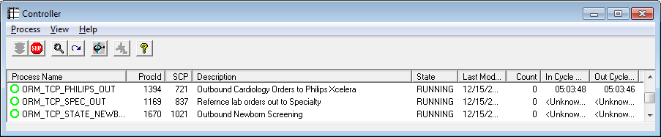

***RESULTS***

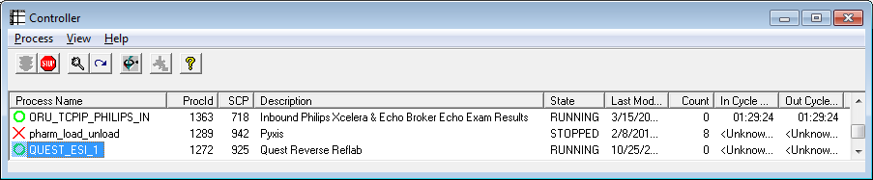

# 4. HL7 Messaging

## 4.1 Messaging Format

* cerner_emr ORU_R01 messages follow HL7 variant version 2.3 inbound and outbound

### 4.1.1 Segments

The segments utilized for this interface are:

MSH

{

[

PID

[ORC]

OBR

[{ZDS}]

[OBX]

}

*Message Construction Notes:*

*[Square Brackets] – Optional*

*MSH – Message Header*

*EVN – Event segment*

*PID – Patient ID segment*

*PV1 – Patient Visit segment*

### 4.1.2 Messaging Event Types

Below are the messages types necessary for this integration

|  |  |
| --- | --- |
| **Event Type** | **Description** |
| ORU_R01 | Result message |

### 4.1*.*3 Cloverleaf Configuration Files

* Translation: xcelera_cer_oru_Disc.xlt

### 4.1.4 Cloverleaf Site Location

* Test and Prod: Cardiology_3

## 4.2 Data Transformation Requirements

### 4.2.1 Cerner Results inbound

| **Field Description** | **HL7 Field Loc.** | **Required Y/N** | **Data Type** | **Length** | **Notes** |
| --- | --- | --- | --- | --- | --- |
| Message Header segment | MSH | Y | Varies | Varies | Path copy the entire MSH segment |
| Sending Application | MSH.3 | Y | HD | 180 | Hard coding “PHILIPS” |
| Sending Facility | MSH.4 | N | HD | 180 | Hard coding “XCELERA” |
| Receiving Application | MSH.5 | Y | HD | 180 | Hard coding “HNAM” |
| Receiving Facility | MSH.6 | Y | HD | 180 | Copy from MSH.5 |
| Version ID | MSH.12 | Y | ID | 8 | Hard code “2.3” |
| Patient ID (Internal) | PID.3.0 | Y | CX | 25 | Copy |
| ID type code | PID.3.4 | Y | CX | 25 | Hard coding “BCCPI” |
| Patient Name: Last, First, Middle | PID.5.0 | Y | XPN | 48 | Path copy |
| Date/Time of Birth | PID.7 | Y | TS | 26 | Copy with TCL pre-proc that trims the seconds off the time |
| Patient Sex | PID.8 | Y | IS | 1 | Copy |
| Patient Account Number | PID.18.0 | Y | CX | 30 | Copy |
| ID Type code | PID.18.4 | Y | CX | 30 | If PID.18.4 = “BMGFN”, copy. Else, hard coding “BCFN” outbound. |
| Order Control | ORC.1 | Y | ID | 2 | Hard coding “RE” |
| Unique Placer ID | ORC.2 | Y | EI | 25 | Copy from ORC.3 |
| Unique Filler ID | ORC.3 | Y | EI | 50 | Copy |
| Set ID | OBR.1 | Y | SI | 4 | Copy |
| Placer Order number | OBR.2 | Y | EI | 25 | Copy |
| Filler Order number | OBR.3 | Y | EI | 22 | Concatenating “LVEF” with OBR.2 |
| Universal Service ID text | OBR.4.0 | Y | CE | 200 | Cloverleaf: Copy from OBR.4.1 |
| Observation Date/Time | OBR.7 | Y | TS | 26 | Copy with TCL pre-proc that trims the seconds off the time |
| Result report status/change | OBR.22 | Y | TS | 26 | Copy with TCL pre-proc that trims the seconds off the time |
| Diagnostic Serv Sect ID | OBR.24 | Y | ID | 10 | Hard coding “GRP” |
| Result status | OBR.25 | Y | ID | 1 | Copy |
| Observation Identifier | OBX.2  OBX.3  OBX.4  OBX.5  OBX.11  OBX.14 | Y |  |  | If OBX.3 = SU-LV0082aa **or** SU-LV0082ab, pathcopy the entire OBX segment. Hard code “ST” in OBX.2, copy OBX.3, OBX.4, OBX.5, OBX.11 and the output of OBR.22 into OBX.14.  ** SU-LV0082aa equates to ejection fraction 40 and above while SU-LV0082ab equates to 39 and below.**  ***Within the OBX.5 copy, there is TCL code that only passes the observation value range***  Before: Ejection Fraction = 35-40%.  After: 35-40% |

## 4.3 Sample Messages

### 4.3.1 Xcelera Inbound

MSH|^~\&|XCELERA|XCELERA|HNAM|MDCDC|20180724134937||ORU^R01|d47d82f320180724134937426|P|2.3||||||8859/1

PID|||810018133^^^MDCDC||MDCTEST^TWO||19750512000000|F|||280 CURLEW RD^^Clearwater^FL^33759||(727)281-9000|||||6000037656

PV1||O|ECHDC MDC||||||||||||||||||||||||||||||||||||MDCDC

ORC|RE||14471013403||CM||||20180724134439|||MS003695^Hobson^Jonathan

OBR|1|14471013403|940277|^Adult^Adult|||20180724134439|20180724134930||||||||MS003695^Hobson^Jonathan||14471013403||1||20180724134929||CUS|F||||||Test|^Hart IV^Spencer|^20180724134439^20180724134930

ZDS|1.3.46.670589.52.2.551502.20180724.5120048.4518.13913

OBX|1|ST|^Interpretation Summary||Interpretation Summary||||||F

OBX|2|ST|SU-0134^Interpretation Summary||No hemodynamically significant valvular abnormalities noted.||||||F

OBX|3|ST|^Left Ventricle||Left Ventricle||||||F

OBX|4|ST|LV-0147^Left Ventricle||Left ventricular size and function appears normal.||||||F

OBX|5|ST|SU-LV0082ab^Left Ventricle||Ejection Fraction = 20-25%.||||||F

OBX|6|ST|^Tricuspid Valve||Tricuspid Valve||||||F

OBX|7|ST|TV-0098^Tricuspid Valve||Doppler findings do not suggest pulmonary hypertension.||||||F

OBX|8|ST|^Pericardium/Pleural||Pericardium/Pleural||||||F

OBX|9|ST|PE-0015^Pericardium/Pleural||There is no pericardial effusion.||||||F

OBX|10|ST|^Conclusion||Conclusion||||||F

OBX|11|ST|Conclusion^Conclusion||Ejection Fraction = 20-25%.||||||F

OBX|12|CE|InterpretingPhysician^InterpretingPhysician||InterpretingPhysician: Spencer Hart IV, electronically signed on 2018-07-24 13:49:29.75||||||F

### 4.3.2 Outbound to Cerner

MSH|^~\&|PHILIPS|XCELERA|HNAM|HNAM|20180724134937||ORU^R01|d47d82f3201807241349|P|2.3||||||8859/1

PID|||810018133^^^^BCCPI||MDCTEST^TWO||19750512|F||||||||||6000037656^^^^BCFN

ORC|RE|14471013403|14471013403

OBR|1|14471013403|14471013403LVEF|Adult|||201807241344|||||||||||||||201807241349||GRP|F

OBX|1|ST|SU-LV0082ab^Left Ventricle||20-25%||||||F|||201807241349

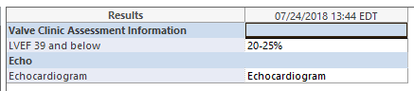

# **5. Alerts**

Are you going to need alerting on this connection?

|  |  |
| --- | --- |
| Yes |  |
| No |  |

If the answer is yes, please complete the table below:

|  |  |  |  |
| --- | --- | --- | --- |
| **Site Name** | **Hours of Support** | **Distribution Group** | **Comments** |
|  |  |  |  |
|  |  |  |  |

# Appendix A: Risks and Concerns -N/A

|  |  |  |  |  |  |  |  |  |
| --- | --- | --- | --- | --- | --- | --- | --- | --- |
| **Project Name** |  |  | | |  |  |  |  |
| **Number** | **Risk / Concern** | **Comment** | **Mitigation** | | |  |  |  |
| RC.2015.2.0 |  |  | |  | |  |  |  |
|  |  |  | |  | |  |  |  |

# Appendix B: Issues List -N/A

This is a dynamic list of the open issues related to the IDBB that remain to be solved, including but not limited to TBDs, pending decisions, information needed, conflict awaiting resolution, and the like.

|  |  |  |  |  |  |  |  |  |
| --- | --- | --- | --- | --- | --- | --- | --- | --- |
| **Project Name** |  |  | | |  |  |  |  |
| **Number** | **Issue** | **Comment** | **Fix** | | |  |  |  |
|  |  |  | |  | |  |  |  |

* End of document